import pandas as pd
import numpy as np
import seaborn as sns
import matplotlib.pyplot as plt
import warnings
warnings.filterwarnings(action="ignore")
from sklearn.model_selection import train_test_split
from sklearn.metrics import accuracy_score, classification_report
from sklearn.ensemble import AdaBoostClassifier
from sklearn.neural_network import BernoulliRBM
from sklearn.preprocessing import StandardScaler
from imblearn.over_sampling import SMOTE
import tensorflow as tf
from tensorflow.keras.models import Sequential
from tensorflow.keras.layers import Dense
from sklearn.metrics import roc_curve, auc
from sklearn import metrics
from sklearn.metrics import confusion_matrix
from sklearn.datasets import make_classification
from sklearn.metrics import accuracy_score, precision_score, recall_score, f1_score
C:\Users\agarw\anaconda3\lib\site-packages\scipy\__init__.py:146: UserWarning: A NumPy version >=1.16.5 and <1.23.0 is required for this version of SciPy (detected version 1.26.2
warnings.warn(f"A NumPy version >={np_minversion} and <{np_maxversion}"
#importing data from the dataset
df = pd.read_csv(r"C:\Users\agarw\OneDrive\Desktop\Dissertation\data.csv")
#checking for bankrupt companies 0 is non-bankrupt and 1 is bankrupt
bankrupt_data = df['Bankrupt?'].value_counts()
bankrupt_data
Bankrupt?
0 6599
1 220
Name: count, dtype: int64
#Distribution representation
plt.figure(figsize = (10,5))
colors = ["#3498db", "#e74c3c"]
ax = sns.countplot(x=df['Bankrupt?'], data=df,palette=colors)
for p in ax.patches:
ax.annotate(f'{p.get_height()}', (p.get_x() + p.get_width() / 2., p.get_height()),
ha='center', va='center', xytext=(0, 10), textcoords='offset points')
# Add labels and title
plt.xlabel('Bankrupt')
plt.ylabel('Count')
plt.title('Distribution of Bankrupt')
# Show the plot
plt.show()
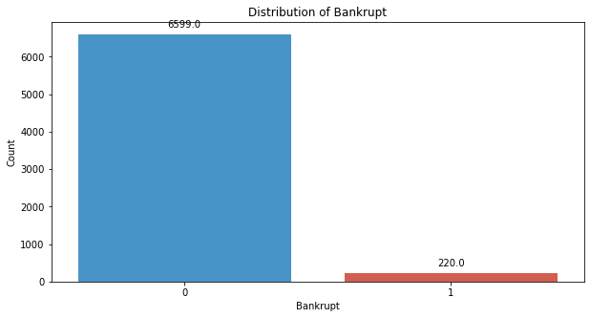
# seperate the Bankrupt label from the dataset
y = df['Bankrupt?']
X = df.drop(['Bankrupt?'], axis = 1)
# divinding our dataset into training dataset
X_train, X_temp, y_train, y_temp = train_test_split(X, y, test_size=0.2, random_state=42)
#Distribution representation
plt.figure(figsize = (10,5))
colors = ["#3498db", "#e74c3c"]
ax = sns.countplot(x=y_train, data=df,palette=colors)
for p in ax.patches:
ax.annotate(f'{p.get_height()}', (p.get_x() + p.get_width() / 2., p.get_height()),
ha='center', va='center', xytext=(0, 10), textcoords='offset points')
# Add labels and title
plt.xlabel('Bankrupt')
plt.ylabel('Count')
plt.title('Distribution of Bankrupt')
# Show the plot
plt.show()
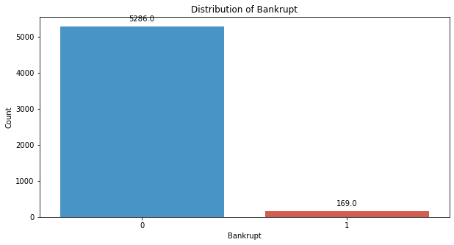
# divinding our dataset into testing and validation
X_val, X_test, y_val, y_test = train_test_split(X_temp, y_temp, test_size=0.5, random_state=42)
smote = SMOTE(sampling_strategy=0.5, random_state=42)
X_train_resampled, y_train_resampled = smote.fit_resample(X_train, y_train)
#Distribution representation
plt.figure(figsize = (10,5))
colors = ["#3498db", "#e74c3c"]
ax = sns.countplot(x=y_train_resampled, data=df,palette=colors)
for p in ax.patches:
ax.annotate(f'{p.get_height()}', (p.get_x() + p.get_width() / 2., p.get_height()),
ha='center', va='center', xytext=(0, 10), textcoords='offset points')
# Add labels and title
plt.xlabel('Bankrupt')
plt.ylabel('Count')
plt.title('Distribution of Bankrupt')
# Show the plot
plt.show()
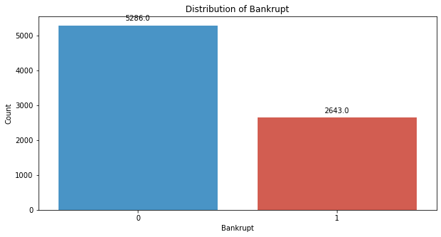
# Standardize the data
scaler = StandardScaler()
X_train_resampled = scaler.fit_transform(X_train_resampled)
X_val = scaler.transform(X_val)
X_test = scaler.transform(X_test)
rbm = BernoulliRBM(n_components=95, n_iter=10, random_state=42)
rbm.fit(X_train_resampled)
BernoulliRBM(n_components=95, random_state=42)
# Transform the data using the trained RBM
X_train_transformed = rbm.transform(X_train_resampled)
X_val_transformed = rbm.transform(X_val)
X_test_transformed = rbm.transform(X_test)
model = tf.keras.Sequential([
tf.keras.layers.Input(shape=(X_train_transformed.shape[1],)),
tf.keras.layers.Dense(64, activation='relu'),
tf.keras.layers.Dropout(0.2),
tf.keras.layers.Dense(32, activation='relu'),
tf.keras.layers.Dropout(0.2),
tf.keras.layers.Dense(1, activation='sigmoid')
])
model.compile(optimizer='adam', loss='binary_crossentropy', metrics=['accuracy'])
model.fit(X_train_transformed, y_train_resampled, epochs=25, batch_size=32, verbose=2)
Epoch 1/25
248/248 - 3s - 11ms/step - accuracy: 0.8449 - loss: 0.3960
Epoch 2/25
248/248 - 1s - 3ms/step - accuracy: 0.8637 - loss: 0.3433
Epoch 3/25
248/248 - 1s - 3ms/step - accuracy: 0.8687 - loss: 0.3366
Epoch 4/25
248/248 - 1s - 2ms/step - accuracy: 0.8688 - loss: 0.3345
Epoch 5/25
248/248 - 1s - 3ms/step - accuracy: 0.8703 - loss: 0.3340
Epoch 6/25
248/248 - 1s - 3ms/step - accuracy: 0.8696 - loss: 0.3342
Epoch 7/25
248/248 - 1s - 2ms/step - accuracy: 0.8695 - loss: 0.3309
Epoch 8/25
248/248 - 1s - 2ms/step - accuracy: 0.8690 - loss: 0.3318
Epoch 9/25
248/248 - 1s - 2ms/step - accuracy: 0.8735 - loss: 0.3314
Epoch 10/25
248/248 - 1s - 2ms/step - accuracy: 0.8720 - loss: 0.3276
Epoch 11/25
248/248 - 1s - 2ms/step - accuracy: 0.8738 - loss: 0.3295
Epoch 12/25
248/248 - 1s - 2ms/step - accuracy: 0.8738 - loss: 0.3250
Epoch 13/25
248/248 - 1s - 2ms/step - accuracy: 0.8733 - loss: 0.3290
Epoch 14/25
248/248 - 1s - 2ms/step - accuracy: 0.8743 - loss: 0.3277
Epoch 15/25
248/248 - 1s - 2ms/step - accuracy: 0.8736 - loss: 0.3283
Epoch 16/25
248/248 - 1s - 2ms/step - accuracy: 0.8736 - loss: 0.3255
Epoch 17/25
248/248 - 1s - 2ms/step - accuracy: 0.8735 - loss: 0.3281
Epoch 18/25
248/248 - 1s - 2ms/step - accuracy: 0.8738 - loss: 0.3273
Epoch 19/25
248/248 - 1s - 2ms/step - accuracy: 0.8740 - loss: 0.3259
Epoch 20/25
248/248 - 1s - 2ms/step - accuracy: 0.8740 - loss: 0.3269
Epoch 21/25
248/248 - 1s - 2ms/step - accuracy: 0.8740 - loss: 0.3266
Epoch 22/25
248/248 - 1s - 2ms/step - accuracy: 0.8741 - loss: 0.3252
Epoch 23/25
248/248 - 1s - 2ms/step - accuracy: 0.8726 - loss: 0.3274
Epoch 24/25
248/248 - 1s - 2ms/step - accuracy: 0.8735 - loss: 0.3237
Epoch 25/25
248/248 - 1s - 2ms/step - accuracy: 0.8744 - loss: 0.3266
<keras.src.callbacks.history.History at 0x17996953700>
#Validation dataset
y_val_pred = (model.predict(X_val_transformed) > 0.5).astype(int)
22/22 ━━━━━━━━━━━━━━━━━━━━ 0s 4ms/step
# Evaluate the model's performance on the validation set
val_accuracy = accuracy_score(y_val, y_val_pred)
precision = precision_score(y_val, y_val_pred)
recall = recall_score(y_val, y_val_pred)
f1_value = f1_score(y_val, y_val_pred)
val_report = classification_report(y_val, y_val_pred)
print("Accuracy", val_accuracy)
print("Precision", precision)
print("Recall", recall)
print("F1 Score", f1_value)
print("Validation Classification Report:\n", val_report)
Accuracy 0.8577712609970675
Precision 0.1592920353982301
Recall 0.9
F1 Score 0.27067669172932335
Validation Classification Report:
precision recall f1-score support
0 1.00 0.86 0.92 662
1 0.16 0.90 0.27 20
accuracy 0.86 682
macro avg 0.58 0.88 0.60 682
weighted avg 0.97 0.86 0.90 682
conf_matrix = confusion_matrix(y_val, y_val_pred)
print("Confusion Matrix")
print(conf_matrix)
Confusion Matrix
[[567 95]
[ 2 18]]
y_test_pred = (model.predict(X_test_transformed) > 0.5).astype(int)
22/22 ━━━━━━━━━━━━━━━━━━━━ 0s 2ms/step
# Evaluate the model's performance on the test set
test_accuracy = accuracy_score(y_test, y_test_pred)
precision = precision_score(y_test, y_test_pred)
recall = recall_score(y_test, y_test_pred)
f1_value = f1_score(y_test, y_test_pred)
test_report = classification_report(y_test, y_test_pred)
print("Accuracy", test_accuracy)
print("Precision", precision)
print("Recall", recall)
print("F1 Score", f1_value)
print("Test Classification Report:\n", test_report)
Accuracy 0.8621700879765396
Precision 0.23076923076923078
Recall 0.8709677419354839
F1 Score 0.3648648648648649
Test Classification Report:
precision recall f1-score support
0 0.99 0.86 0.92 651
1 0.23 0.87 0.36 31
accuracy 0.86 682
macro avg 0.61 0.87 0.64 682
weighted avg 0.96 0.86 0.90 682
conf_matrix = confusion_matrix(y_test, y_test_pred)
print("Confusion Matrix")
print(conf_matrix)
Confusion Matrix
[[561 90]
[ 4 27]]
# Compute ROC curve and ROC area for each class
fpr_val, tpr_val, _ = roc_curve(y_val, y_val_pred)
roc_auc_val = auc(fpr_val, tpr_val)
fpr_test, tpr_test, _ = roc_curve(y_test, y_test_pred)
roc_auc_test = auc(fpr_test, tpr_test)
# Plot ROC curve
plt.figure(figsize=(8, 8))
plt.plot(fpr_val, tpr_val, color='darkorange', lw=2, label=f'Validation ROC curve (area = {roc_auc_val:.2f})')
plt.plot(fpr_test, tpr_test, color='green', lw=2, label=f'Test ROC curve (area = {roc_auc_test:.2f})')
plt.plot([0, 1], [0, 1], color='navy', lw=2, linestyle='--')
plt.xlim([0.0, 1.0])
plt.ylim([0.0, 1.05])
plt.xlabel('False Positive Rate')
plt.ylabel('True Positive Rate')
plt.title('Receiver Operating Characteristic (ROC) Curve')
plt.legend(loc="lower right")
plt.show()
